Clin Infect Dis. 2015 Mar 1; 60(5): 693–702.
Published online 2014 Nov 20. doi: 10.1093/cid/ciu924
PMCID: PMC4342672
PMID: 25416753

Validation of the Wild-type Influenza A Human Challenge Model H1N1pdMIST: An A(H1N1)pdm09 Dose-Finding Investigational New Drug Study

https://www.ncbi.nlm.nih.gov/pmc/articles/PMC4342672/

Matthew J. Memoli,¹ Lindsay Czajkowski,¹ Susan Reed,¹ Rani Athota,¹ Tyler Bristol,¹ Kathleen Proudfoot,¹ Sarah Fargis,¹ Matthew Stein,¹ Rebecca L. Dunfee,¹ Pamela A. Shaw,² Richard T. Davey,³ and Jeffery K. Taubenberger¹
Author information Article notes Copyright and License information Disclaimer
This article has been cited by other articles in PMC.
Associated Data
Supplementary Materials
Go to:
- Abstract
Background. Healthy volunteer wild-type influenza challenge models offer a unique opportunity to evaluate multiple aspects of this important virus. Such studies have not been performed in the United States in more than a decade, limiting our capability to investigate this virus and develop countermeasures. We have completed the first ever wild-type influenza A challenge study under an Investigational New Drug application (IND). This dose-finding study will lead to further development of this model both for A(H1N1)pdm09 and other strains of influenza.
Methods. Volunteers were admitted to an isolation unit at the National Institutes of Health Clinical Center for a minimum of 9 days. A reverse genetics, cell-based, Good Manufacturing Practice (GMP)–produced, wild-type A(H1N1)pdm09 virus was administered intranasally. Escalating doses were given until a dose was reached that produced disease in a minimum of 60% of volunteers.
Results. An optimal dose of 10⁷ tissue culture infectious dose 50 was reached that caused mild to moderate influenza disease in 69% of individuals with mean viral shedding for 4–5 days and significant rises in convalescent influenza antibody titers. Viral shedding preceded symptoms by 12–24 hours and terminated 2–3 days prior to symptom resolution, indicating that individuals may be infectious before symptom development. As expected, nasal congestion and rhinorrhea were most common, but interestingly, fever was observed in only 10% of individuals.
Conclusions. This study represents the first healthy volunteer influenza challenge model using a GMP-produced wild-type virus under an IND. This unique clinical research program will facilitate future studies of influenza pathogenesis, animal model validation, and the rapid, efficient, and cost-effective evaluation of efficacy of novel vaccines and therapeutics.
Clinical Trials Registration. NCT01646138.
Keywords: influenza, H1N1, healthy volunteer, influenza A, challenge
The unpredictable nature and public health importance of influenza as a cause of human disease has been highlighted in recent years by the identification of new zoonotic avian influenza infections [1], the emergence of a pandemic in 2009 [2], and the continued significant morbidity and mortality associated with seasonal influenza [3]. Despite nearly 100 years of effort, our ability to study the basic pathogenesis of influenza in humans and efficiently evaluate novel therapeutics and vaccines is limited due to the inherent difficulty of conducting clinical studies of this acute viral respiratory illness. Animal models also have limitations, particularly when investigating questions of human adaptation, correlates of immunoprotection, transmission, host response, biomarkers, and risk factors for severe disease. Therefore, current evaluation of novel diagnostics, therapeutics, and vaccines are arduous, costly, and require large numbers of participants, with endpoints that can be difficult to evaluate [4]. These complications make pandemic preparedness and reduction of influenza morbidity and mortality a daunting task.
A well-characterized healthy volunteer challenge model of influenza, although not without limitations [5], offers a number of advantages that cannot be achieved in studies of those naturally infected. Control of the host can be achieved through inclusion and exclusion based on factors such as age, preexisting immunity, and vaccination status. Administration of a challenge virus with a known infection rate in healthy volunteers, for example, allows for efficient design of phase 2 efficacy studies for novel therapeutics or vaccines with statistically valid endpoints and fewer assumptions. Most important, timing of the infection is known in a challenge model allowing for collection of samples and data pre and postchallenge at absolute time points, something that is impossible in a study of those naturally infected or exposed.
Previous human challenge studies have been safely performed since the 1930s [6, 7] to address many aspects of influenza natural history by evaluating the timing of viral replication, shedding, clinical symptoms, and innate and adaptive immune responses [8–20]. They also played an integral part in the development of current influenza antivirals and vaccines [21–23]. Although these studies have provided important information, only a small number of these studies have been performed since the 1990s [22–25]. In the last decade, no influenza challenge studies have been performed in the United States, and outside the United States, only a small number of studies have been performed [26–29], none of which have sought to create a robust well-described model under an Investigational New Drug application (IND). Renewed interest in developing improved or new broadly reactive “universal” vaccines [30] along with other novel therapeutics [4] has made this the opportune time to reestablish influenza challenge studies; new and improved scientific tools unavailable for previous challenge studies, such as multiplex molecular diagnostics, gene expression arrays, and next-generation sequencing, add further value to these studies.
In this study we sought to develop the first human challenge model under an IND for a wild-type A(H1N1)pdm09 influenza virus. This initial study was designed to identify the dose needed to induce mild to moderate influenza disease (MMID) in healthy volunteers after intranasal inoculation and comprehensively describe the attack rates, basic host response, and clinical disease induced by infection in this model.
Go to:
- METHODS
- Study Design
This was a prospective-dose escalation study in healthy volunteers at the National Institutes of Health (NIH) Clinical Center. The primary objective was to determine the infectious dose of influenza A(H1N1)pdm09 that induced uncomplicated MMID in at least 60% of healthy volunteers with hemagglutination inhibition (HAI) titers of ≤1:40. MMID was defined as viral shedding detected by clinical molecular testing, plus the onset of at least 1 acute influenza-like illness symptom after intranasal challenge. Dose escalation was performed as shown in Supplementary Figure 1.
Intranasal challenge was carried out using the MAD Nasal sprayer device (Wolfe-Tory Medical, Salt Lake City, Utah) attached to a 1-mL syringe. Five hundred microliters of virus diluted in sterile saline was delivered in each nostril of a recumbent participant. All participants were required to remain in isolation for a minimum of 9 days. Participants were discharged after having 2 negative nasal washes on consecutive days. Participants were then followed every 2 weeks for 2 months after discharge. All participants had prechallenge symptom evaluation, blood collection, chest computed tomography (CT), electrocardiography (ECG), echocardiography, pulmonary function testing (PFT), and nasal wash. After challenge routine vital signs every 8 hours, clinical evaluation, ECG, blood collection, symptom evaluation, and nasal washes were performed daily, and chest CT was performed 6 days and echocardiography was performed 3 and 6 days postchallenge. Blood collection, PFT, and ECG were performed at outpatient follow-up visits.
The study (ClinicalTrials.gov identifier NCT01646138) was approved by the National Institute of Allergy and Infectious Diseases institutional review board and underwent an ethics review by the NIH Department of Bioethics prior to being conducted. The study was conducted in accordance with the provisions of the Declaration of Helsinki and Good Clinical Practice guidelines.
- Participants
Volunteers were enrolled between April 2012 and June of 2013. Eligible volunteers were nonsmokers between the ages of 18 and 50, had no known medical problems, and had prechallenge HAI titers of ≤1:40 a maximum of 2 months in advance. Exclusion criteria included body mass index ≤ 18.5 or ≥40 kg/m² or close contact with persons aged ≤5 or ≥65 years, residents of nursing homes, pregnant women, children receiving long-term aspirin therapy, or persons with significant chronic medical conditions. Substance abuse, alcoholism, and psychiatric illness were also exclusionary. No participant had received any blood products, experimental drug, or vaccine within 6 months of the study.
- Virus
The virus was rescued using standard reverse genetics [31] in a certified cell line derived from World Health Organization Vero reference cell bank 10–87. The plasmids were made by cloning the 8 viral gene segments of the wild-type A/CA/04/2009(H1N1). The viral seed stock was used for Good Manufacturing Practice (GMP) manufacturing of the challenge strain in the Vero cells. Sequencing revealed only 3 amino acid changes from the original wild-type isolate after manufacturing (PA:G58S, HA:A388V, and NA:E119K). Experimental infections of ferrets and mice comparing the GMP challenge strain to the initial isolate demonstrated no differences in infectivity, pathology, or viral fitness (Supplementary Figures 2–6). A US Food and Drug Administration (FDA) IND (No. BB-IND 14969) was obtained, and this study was carried out as a phase 1 trial.
- Symptom Evaluation
Influenza symptoms evaluated are listed in Supplementary Table 2. A symptom checklist was administered by the examining physician daily during the inpatient stay and at follow-up visits, and a symptom questionnaire was completed every morning and evening for 14 days continuously by the participants.
- Immune Response
Serum cytokines were measured using the Human Cytokine 17-plex assay on a Bio-Rad Bio-Plex 200 (Bio-Rad Hercules, California). HAI and neuraminidase inhibition (NAI) titers were measured using standard methods [32, 33]. Results for all assays were compiled and statistical analysis was performed using GraphPad Prism software (GraphPad, La Jolla, California).
- Viral Quantitation
Nasal washes were analyzed using 1-step real-time quantitative reverse transcription polymerase chain reaction for the influenza A virus matrix 1 gene [34]. A standard curve with an external standard was used to calculate copy number.
- Statistical Methods
Statistical significance of prevalence of MMID (Table ​(Table1)1) in the different dose groups was tested using a 2-tailed Fisher exact test with P < .05 being considered significant. Two-tailed 95% confidence intervals were calculated in GraphPad Prism for the geometric mean HAI and NAI titers. Nonoverlapping confidence intervals were considered significant.
- Table 1.
Dose Escalation Results
Dose | Male | Female | Total | Symptoms | Viral Shedding | Both (MMID) | 4-Fold Rise in HAI Titer
10³ TCID₅₀ | 3 | 2 | 5 | 2 (40%) | 0 | 0 | 1 (20%)
10⁴ TCID₅₀ | 4 | 0 | 4 | 2 (50%) | 0 | 0 | 0
10⁵ TCID₅₀ | 2 | 3 | 5 | 4 (80%) | 1 (20%) | 1 (20%) | 1 (20%)
10⁶ TCID₅₀ | 10 | 9 | 19 | 17 (89%) | 9 (47%) | 9 (47%) | 16 (84%)
10⁷ TCID₅₀ | 9 | 4 | 13 | 11 (85%) | 10 (77%) | 9 (69%) | 11 (85%)
Total | 28 | 18 | 46 | 36 (78%) | 20 (43%) | 19 (41%) | 29 (63%)
Data are presented as No. (%).
Abbreviations: HAI, hemagglutination inhibition; MMID, mild to moderate influenza disease; TCID₅₀, tissue culture infectious dose 50.
Go to:
- RESULTS
Forty-nine healthy participants were enrolled. The mean age of the participants was 29.2 years. Six participants had a positive respiratory virus panel for something other than influenza and were disqualified, but 3 returned for future challenge a minimum of 1 month later. Ultimately, 46 participants were challenged (Supplementary Table 1).
The primary objective was reached at the 10⁷ tissue culture infectious dose 50 (TCID₅₀) dose (Table ​(Table1).1). In that group, 69% of participants met the criteria for MMID, well over the goal of 60% and statistically higher than the lowest 2 doses evaluated, 10³ and 10⁴ TCID₅₀ (P = .029 for both). The 10⁵ and 10⁶ TCID₅₀ doses also induced MMID (20% and 47%, respectively) in a larger number of participants compared with the lower doses, but did not meet the initial criteria of 60% and was not statistically different from the lowest dose given (P = .99 and P = .054, respectively).
Clinical symptoms of influenza occurred at all doses (Table ​(Table1),1), but were most prevalent at 10⁶ and 10⁷ TCID₅₀. Symptoms generally began within 24–72 hours of challenge (Figure ​(Figure11A and ​and11E), and lasted about 8 days at the dose of 10⁷ TCID₅₀. A small number of participants experienced mild lingering symptoms. The most commonly experienced symptoms in those with MMID included rhinorrhea, nasal/sinus congestion, sore throat, headache, and fatigue (Supplementary Table 2). Fever was identified in 10% of participants. Participants who did not have detectable shedding experienced less clinical illness (Figure ​(Figure11C), but >30% still experienced some of the more common symptoms (Supplementary Table 2).

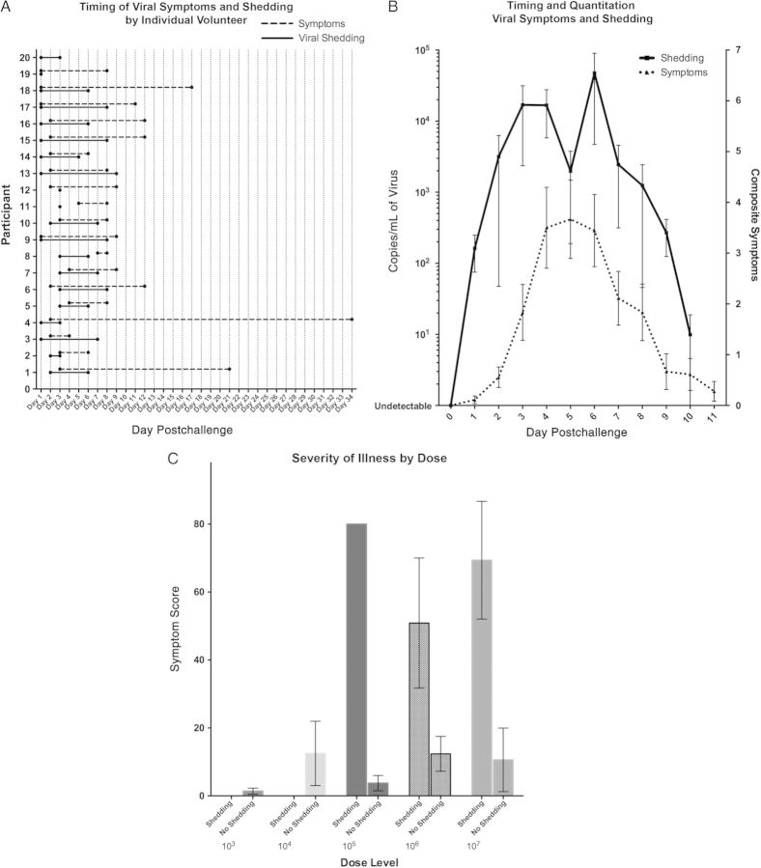
Open in a separate window

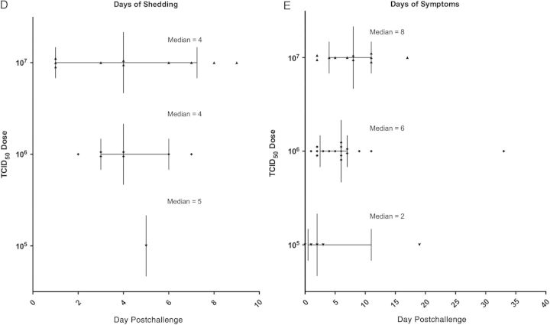
Figure 1.
Viral shedding and clinical illness. A, Timing of symptoms and viral shedding for each individual participant who tested positive for influenza A by multiplex respiratory testing during their inpatient stay. Shedding typically began within 24–48 hours of challenge (solid line), and symptoms typically began 24–48 hours after shedding but lasted longer (dashed line). One participant (number 20) shed virus for 3 days without manifestation of symptoms. B, Aggregate quantitation of viral shedding (solid line) and correlation to number of symptoms each day (dashed line) during the inpatient stay (± standard error of the mean [SEM]). C, Mean severity of illness as measured by overall disease clinical score (number of symptoms multiplied by overall duration of symptoms) by dose group and positive or negative influenza shedding during inpatient stay. D, Days of shedding at the 3 doses that produced participants with positive nasal washes (± interquartile range [IQR]). E, Days of symptoms in the top 3 doses of all participants regardless of positive or negative nasal influenza viral shedding (±IQR). Abbreviation: TCID₅₀, tissue culture infectious dose 50.
Viral shedding was detected typically within 24–48 hours postchallenge, and often 12–24 hours prior to the onset of symptoms. The length of viral shedding was found to be 4–5 days, with some participants shedding virus up to 9 days (Figure ​(Figure11A and ​and11D). Quantitation demonstrated that peak shedding occurred for most participants between day 3 and day 6, with approximately 10⁴–10⁵ viral copies/mL of nasal wash (Figure ​(Figure11B). Number and severity of symptoms correlated well with viral shedding (Figure ​(Figure11B and ​and11C), but as noted, symptoms typically lagged behind viral shedding and often lasted days longer (Figure ​(Figure11A and ​and11E).
Lower respiratory tract and/or cardiac signs and symptoms were uncommon, and no severe complications were identified. Three participants had abnormal pulmonary exams and 3 other participants had abnormalities on CT postchallenge. All of these participants received one of the highest 2 doses, and all abnormalities were clinically insignificant, but did include new tiny diffuse bilateral lung nodules in 1 case and evidence of early consolidation in the right middle lobe in another. PFTs demonstrated a mild decrease in diffusing capacity for lung carbon monoxide in those who met criteria for MMID, but this difference was not statistically significant. No changes in echocardiography were noted postchallenge, and no significant changes in cardiac examination or ECG were noted except for transient episodes of tachycardia related to fever.
A strong immune response was observed as 63% of all participants and 85% who received 10⁷ TCID₅₀ demonstrated a ≥4-fold rise in HAI titer by week 8 regardless of viral shedding or the development of symptoms (Table ​(Table1).1). At the 3 lowest doses, no demonstrable rise in geometric mean antibody titer (GMT) against hemaglutinin (HA) or neuraminidase (NA) was detected, but at the 2 highest doses a significant rise in both titers was seen (Figure ​(Figure2).2). The 10⁷ dose induced the strongest rise in GMT against both NA and HA. Baseline antibody titers to both HA and NA were inversely correlated with disease severity (Figure ​(Figure3).3). An early significant rise in the serum cytokines interleukin 6 (IL-6), tumor necrosis factor alpha (TNF-α), interferon gamma (IFN-γ), and granulocyte colony-stimulating factor (G-CSF) was observed in those who met MMID, whereas there was a late rise in the same cytokines in those who did not, driven primarily by those individuals who had symptoms of influenza infection without detectable shedding of virus (Figure ​(Figure44).

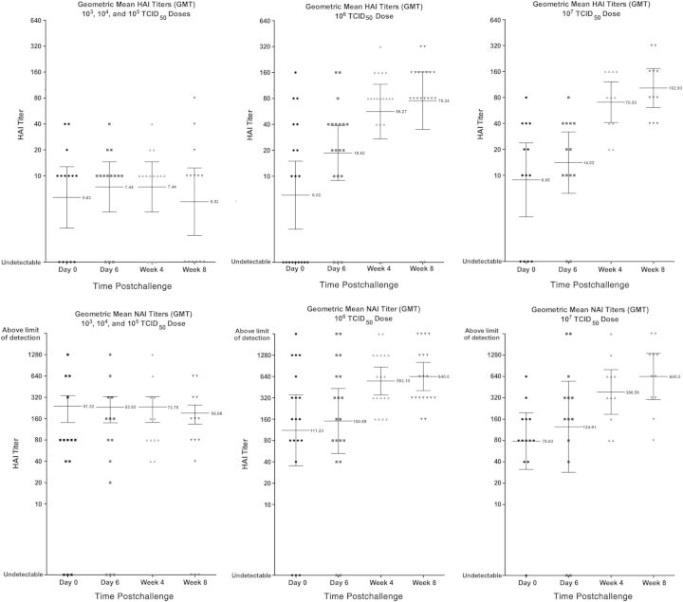
Open in a separate window
Figure 2.
Antibody response. Geometric mean titer (GMT) of all challenge participants at different time points of both hemagglutination inhibition (HAI; top) and neuraminidase inhibition titers (NAI; bottom) pre- and postchallenge in the 3 low-dose groups (combined) and each of the 2 high-dose groups (shown separately). Error bars represent 95% confidence intervals. No significant change in GMT was noted for either HAI or NAI at the lowest 3 doses, whereas statistically significant changes were seen at the 2 higher doses. Participants were enrolled if their screening HAI titer was ≤1:40, approximately 8 weeks prior to challenge. For 4 participants in the 10⁶ and 10⁷ tissue culture infectious dose 50 (TCID₅₀) groups, day 0 titers were 1:80 or 1:160, suggesting influenza exposure between screening and challenge.

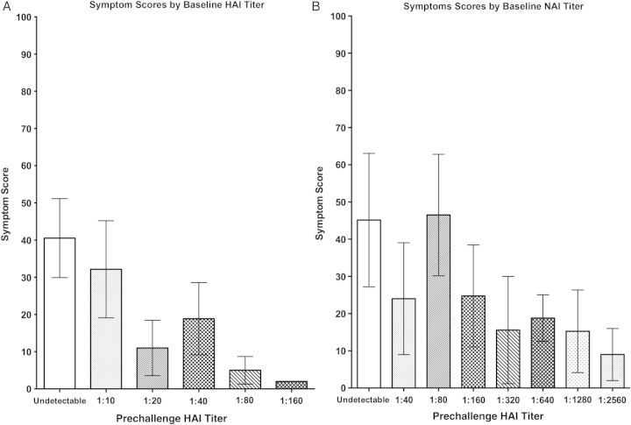
Figure 3.
Clinical score observed by baseline hemagglutination inhibition (HAI) and neuraminidase inhibition (NAI) titers (A and B, respectively). Mean clinical score (number of symptoms multiplied by overall duration of symptoms in days) of all participants (regardless of presence or absence of viral shedding) at different baseline HAI and NAI titers is shown (± standard error of the mean [SEM]). Overall, there was a trend, for both HAI and NAI independently, that those with a higher baseline titer had a shorter duration and smaller number of clinical symptoms.

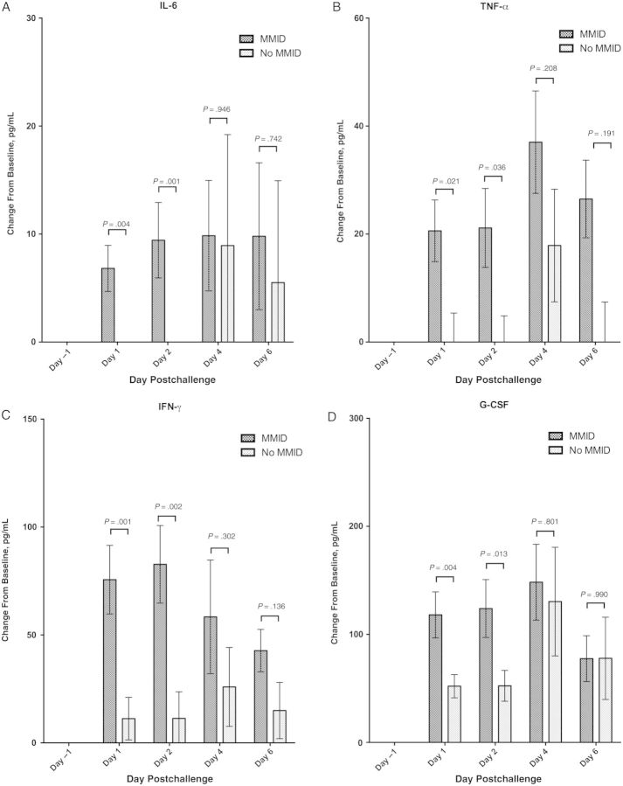
Open in a separate window
Figure 4.
Cytokine response. Mean rise in interleukin 6 (IL-6), tumor necrosis factor alpha (TNF-α), interferon gamma (IFN-γ), and granulocyte colony-stimulating factor (G-CSF) in all participants both pre- and postchallenge, separated by those who met criteria for mild to moderate influenza disease (MMID), and those who did not (± standard error of the mean [SEM]). Significance is noted by P value between MMID and no MMID by day.
Go to:
- DISCUSSION
This study represents the first time a wild-type influenza virus challenge of healthy human volunteers has been performed using a reverse genetics–produced virus under an IND, and serves as a standardized model for future healthy volunteer challenge studies with A(H1N1)pdm09 and other wild-type circulating influenza strains. The dose of 10⁷ TCID₅₀ administered intranasally using a nasal atomizer was clearly the most effective at producing upper respiratory viral infection and clinical influenza symptoms in participants compared with lower doses of inoculum. The model performed extremely well with nearly 70% of participants showing both viral shedding and symptoms, and an even higher percentage in those with undetectable HAI titers at baseline. The model correlates well with natural infection, making it an invaluable tool for studying the clinical, virological, and immunological parameters of self-limited human influenza illness and as a basis for phase 2 efficacy studies of novel therapeutics and vaccines.
The clinical illness observed was mild to moderate, predominantly upper respiratory as intended, with the diversity and mean duration of influenza symptoms typically observed in natural infection. Interestingly, even in a homogeneous population of healthy young adults, a wide spectrum of illness duration was observed, with a minority of individuals having lingering symptoms well beyond 1–2 weeks. Of clinical note was the infrequent development of fever in those who became ill, with only 10% observed to have a temperature >38°C. Although natural history studies have reported fever in approximately 80% of cases [35], those studies generally only capture data on individuals who are medically attended, and fever may be one of the acute reasons a person seeks medical attention. This observation that fever may not be a common clinical indicator of mild to moderate influenza-induced illness in healthy individuals was made due to the unique context of the challenge model that allows for study of less severe clinical illness that is often not captured by natural history studies.
A key benefit of this model is the ability to examine virological aspects of disease and correlate them clinically and immunologically in a manner not possible in natural history studies where timing of initial infection cannot be determined with specificity. In this model, symptom onset began 12–24 hours after the participants had detectable virus in their nasopharynx and generally 24–48 hours after viral exposure, with a significant number of symptoms developing 72 hours after challenge. One individual had detectable viral shedding for 3 days without development of symptoms. This reiterates that for 12–72 hours, or in some cases even longer, individuals may be infectious before they develop clinically significant symptoms, contributing significantly to disease spread, missed diagnoses, and epidemiologic errors.
Uniquely in the challenge model, this initial window, from timed viral exposure to development of symptoms, provides an opportunity for diagnostic and prognostic biomarker discovery, whether using molecular genetic or proteomic analyses. Also, participants may show peak shedding with high titers of virus for several days but only manifest mild symptoms. Collectively, these observations of healthy volunteers in the challenge study may be useful in designing and implementing infection control and mitigation strategies during influenza epidemics and pandemics.
Significant rises in serum antibody titers against the influenza A virus hemagglutinin, as assessed by HAI, were observed in the cohorts receiving the 2 highest challenge virus doses (Table ​(Table1;1; Figure ​Figure2)2) and mimicked natural infection well [36]. Of note were those who seroconverted while having minimal clinical illness and no shedding, an important group to consider when interpreting seroepidemiologic studies after epidemics. Serum antibody titers against the viral NA, as assessed by NAI, were much higher at baseline than the corresponding HAI titers, and although NAI titers were not used in screening, a significant rise in NAI titers was also seen in the 2 high-dose cohorts. Both HAI and NAI GMTs rose from the day of inoculation through the end of the 8-week period of analysis (Figure ​(Figure2).2). Also of note was that individuals with higher baseline NAI or HAI titers independently experienced reduced symptoms and severity of disease compared to those with lower baseline titers (Figure ​(Figure3),3), supporting prior studies that antibodies against NA play a role in reducing severity of disease [37].
An acute inflammatory response to influenza challenge was noted by analysis of serum cytokines, the most significant of which during the challenge were IL-6, G-CSF, IFN-γ, and TNF-α, similar to previously published studies [35]. Of note is the statistically significant early rise in these cytokines in individuals who met criteria of MMID (Figure ​(Figure4).4). In those who did not shed virus and thus did not meet criteria for MMID, smaller increases in these cytokines were observed with delayed kinetics for most of these cytokines, especially in those individuals who developed symptoms without detectable shedding.
Go to:
- CONCLUSIONS
This study sought to define a dose of challenge virus that could reliably cause self-limited, mild to moderate influenza in the majority of participants that mimics natural disease. Subsequent influenza challenge studies will include evaluation of other contemporary or future circulating influenza seasonal strains of H1N1, H3N2, and influenza B strains. This model will also facilitate identification of correlates of immunoprotection by associating the development of both adaptive and innate immune responses to virological and clinical endpoints, identification of prognostic or diagnostic biomarkers, validation of experimental animal models, and further definition of the basic pathogenesis of mild to moderate clinical influenza. It can be applied to evaluate novel therapeutics and vaccines in a rapid and efficiently controlled setting in phase 2 efficacy trials, assessing parameters that are generally impossible in natural history studies, such as preexisting immune status, viral dose, and exact kinetics of infection.
No completely novel therapeutics or vaccines have been approved by the FDA for influenza since the last time healthy human volunteer challenge was performed in the United States, and after almost a century since the 1918 pandemic, we still have an incomplete understanding of influenza pathogenesis, correlates of protection, and mechanisms of human adaptation. Thus, it is clear that the human challenge model is an important tool to advance our ability to treat and prevent influenza. Further expansion of this model should be a priority and will be extraordinarily informative for the development of new drugs and vaccines as well as strategic planning for both seasonal and pandemic influenza.
Go to:
- Supplementary Data
Supplementary materials are available at Clinical Infectious Diseases online (http://cid.oxfordjournals.org). Supplementary materials consist of data provided by the author that are published to benefit the reader. The posted materials are not copyedited. The contents of all supplementary data are the sole responsibility of the authors. Questions or messages regarding errors should be addressed to the author.
Supplementary Data:
Click here to view.
Go to:
- Notes
Acknowledgments. The authors acknowledge Dr H. Clifford Lane, the National Institutes of Health Clinical Center Special Clinical Studies Unit staff, and the Department of Laboratory Medicine for their support of this clinical protocol; Dr Steven Whitehead for supplying the Vero Cell line; and Dr Maryna Eichelberger for her assistance in setting up the neuraminidase inhibition assay.
Author contributions. M. J. M. was the lead scientist for this work leading all aspects including the study design, clinical protocol implementation, laboratory studies, and data analysis/manuscript preparation. All other authors played a significant role in 1 or more of the following areas: study design and implementation, generation of data, and preparation of the manuscript.
Financial support. This work was supported by the Intramural Research Program of the National Institute of Allergy and Infectious Diseases (NIAID), as well as the NIAID Extramural Clinical Research Acceleration Program.
Potential conflicts of interest. All authors: No potential conflicts.
All authors have submitted the ICMJE Form for Disclosure of Potential Conflicts of Interest. Conflicts that the editors consider relevant to the content of the manuscript have been disclosed.
Go to:
- References
1. Morens DM, Taubenberger JK, Fauci AS. H7N9 avian influenza A virus and the perpetual challenge of potential human pandemicity. mBio. 2013;4 doi:10.1128/mBio.00445-13. [PMC free article] [PubMed] [Google Scholar]
2. Garten RJ, Davis CT, Russell CA, et al. Antigenic and genetic characteristics of swine-origin 2009 A(H1N1) influenza viruses circulating in humans. Science. 2009;325:197–201. [PMC free article] [PubMed] [Google Scholar]
3. Centers for Disease C, Prevention. Estimates of deaths associated with seasonal influenza—United States, 1976–2007. MMWR Morb Mortal Wkly Rep. 2010;59:1057–62. [PubMed] [Google Scholar]
4. Hayden FG. Newer influenza antivirals, biotherapeutics and combinations. Influenza Other Respir Viruses. 2013;7(suppl 1):63–75. [PMC free article] [PubMed] [Google Scholar]
5. Hayden FG. Experimental human influenza: observations from studies of influenza antivirals. Antivir Ther. 2012;17(1 pt B):133–41. [PubMed] [Google Scholar]
6. Smorodintseff AA, Tushinsky MD, Drobyshevskaya AI, Korovin AA, Osetroff AI. Investigation on volunteers infected with the influenza virus. Am J Med Sci. 1937;194:159–70. [Google Scholar]
7. Francis F. Intranasal inoculation of human individuals with the virus of epidemic influenza. P Soc Exp Biol Med. 1940;43:337–9. [Google Scholar]
8. Anderson MJ, Heath RB. Cell mediated immunity in experimental influenza and parainfluenza infection. Dev Biol Stand. 1977;39:379–83. [PubMed] [Google Scholar]
9. Brown TA, Murphy BR, Radl J, Haaijman JJ, Mestecky J. Subclass distribution and molecular form of immunoglobulin A hemagglutinin antibodies in sera and nasal secretions after experimental secondary infection with influenza A virus in humans. J Clin Microbiol. 1985;22:259–64. [PMC free article] [PubMed] [Google Scholar]
10. Carrat F, Vergu E, Ferguson NM, et al. Time lines of infection and disease in human influenza: a review of volunteer challenge studies. Am J Epidemiol. 2008;167:775–85. [PubMed] [Google Scholar]
11. Clements ML, Snyder MH, Buckler-White AJ, Tierney EL, London WT, Murphy BR. Evaluation of avian-human reassortant influenza A/Washington/897/80 x A/Pintail/119/79 virus in monkeys and adult volunteers. J Clin Microbiol. 1986;24:47–51. [PMC free article] [PubMed] [Google Scholar]
12. Cretescu L, Beare AS, Schild GC. Formation of antibody to matrix protein in experimental human influenza A virus infections. Infect Immun. 1978;22:322–7. [PMC free article] [PubMed] [Google Scholar]
13. Dolin R, Richman DD, Murphy BR, Fauci AS. Cell-mediated immune responses in humans after induced infection with influenza A virus. J Infect Dis. 1977;135:714–9. [PubMed] [Google Scholar]
14. Hayden FG, Fritz R, Lobo MC, Alvord W, Strober W, Straus SE. Local and systemic cytokine responses during experimental human influenza A virus infection. Relation to symptom formation and host defense. J Clin Invest. 1998;101:643–9. [PMC free article] [PubMed] [Google Scholar]
15. Kasel JA, Alford RH, Knight V, Waddell GH, Sigel MM. Experimental infection of human volunteers with equine influenza virus. Nature. 1965;206:41–3. [PubMed] [Google Scholar]
16. Kasel JA, Couch RB. Experimental infection in man and horses with influenza A viruses. Bull World Health Organ. 1969;41:447–52. [PMC free article] [PubMed] [Google Scholar]
17. Rudenko LG, Shadrin AS, Geiker VI, Zibina EA, Zykov MP. Associated seroconversions to respiratory viruses in volunteers with experimental influenza infection. Acta Virol. 1976;20:135–41. [PubMed] [Google Scholar]
18. Scheinberg M, Blacklow NR, Goldstein AL, Parrino TA, Rose FB, Cathcart ES. Influenza: response of T-cell lymphopenia to thymosin. N Engl J Med. 1976;294:1208–11. [PubMed] [Google Scholar]
19. Snyder MH, Clements ML, Herrington D, London WT, Tierney EL, Murphy BR. Comparison by studies in squirrel monkeys, chimpanzees, and adult humans of avian-human influenza A virus reassortants derived from different avian influenza virus donors. J Clin Microbiol. 1986;24:467–9. [PMC free article] [PubMed] [Google Scholar]
20. Alford RH, Kasel JA, Gerone PJ, Knight V. Human influenza resulting from aerosol inhalation. Proc Soc Exp Biol Med. 1966;122:800–4. [PubMed] [Google Scholar]
21. Hayden FG, Treanor JJ, Fritz RS, et al. Use of the oral neuraminidase inhibitor oseltamivir in experimental human influenza: randomized controlled trials for prevention and treatment. JAMA. 1999;282:1240–6. [PubMed] [Google Scholar]
22. Hayden FG, Jennings L, Robson R, et al. Oral oseltamivir in human experimental influenza B infection. Antivir Ther. 2000;5:205–13. [PubMed] [Google Scholar]
23. Barroso L, Treanor J, Gubareva L, Hayden FG. Efficacy and tolerability of the oral neuraminidase inhibitor peramivir in experimental human influenza: randomized, controlled trials for prophylaxis and treatment. Antivir Ther. 2005;10:901–10. [PubMed] [Google Scholar]
24. Gubareva LV, Kaiser L, Matrosovich MN, Soo-Hoo Y, Hayden FG. Selection of influenza virus mutants in experimentally infected volunteers treated with oseltamivir. J Infect Dis. 2001;183:523–31. [PubMed] [Google Scholar]
25. Gentile DA, Doyle WJ, Fireman P, Skoner DP. Effect of experimental influenza A infection on systemic immune and inflammatory parameters in allergic and nonallergic adult subjects. Ann Allergy Asthma Immunol. 2001;87:496–500. [PubMed] [Google Scholar]
26. Huang KY, Li CK, Clutterbuck E, et al. Virus-specific antibody secreting cell, memory B-cell, and sero-antibody responses in the human influenza challenge model. J Infect Dis. 2014;209:1354–61. [PubMed] [Google Scholar]
27. Wilkinson TM, Li CK, Chui CS, et al. Preexisting influenza-specific CD4+ T cells correlate with disease protection against influenza challenge in humans. Nat Med. 2012;18:274–80. [PubMed] [Google Scholar]
28. Killingley B, Enstone JE, Greatorex J, et al. Use of a human influenza challenge model to assess person-to-person transmission: proof-of-concept study. J Infect Dis. 2012;205:35–43. [PubMed] [Google Scholar]
29. Jones S, Evans K, McElwaine-Johnn H, et al. DNA vaccination protects against an influenza challenge in a double-blind randomised placebo-controlled phase 1b clinical trial. Vaccine. 2009;27:2506–12. [PubMed] [Google Scholar]
30. Yewdell JW. To dream the impossible dream: universal influenza vaccination. Curr Opin Virol. 2013;3:316–21. [PMC free article] [PubMed] [Google Scholar]
31. Fodor E, Devenish L, Engelhardt OG, Palese P, Brownlee GG, Garcia-Sastre A. Rescue of influenza A virus from recombinant DNA. J Virol. 1999;73:9679–82. [PMC free article] [PubMed] [Google Scholar]
32. Potter CW, Oxford JS. Determinants of immunity to influenza infection in man. Br Med Bull. 1979;35:69–75. [PubMed] [Google Scholar]
33. Wan H, Gao J, Xu K, et al. Molecular basis for broad neuraminidase immunity: conserved epitopes in seasonal and pandemic H1N1 as well as H5N1 influenza viruses. J Virol. 2013;87:9290–300. [PMC free article] [PubMed] [Google Scholar]
34. Krafft AE, Russell KL, Hawksworth AW, et al. Evaluation of PCR testing of ethanol-fixed nasal swab specimens as an augmented surveillance strategy for influenza virus and adenovirus identification. J Clin Microbiol. 2005;43:1768–75. [PMC free article] [PubMed] [Google Scholar]
35. Memoli MJ, Athota R, Reed S, et al. The natural history of influenza infection in the severely immunocompromised vs nonimmunocompromised hosts. Clin Infect Dis. 2014;58:214–24. [PMC free article] [PubMed] [Google Scholar]
36. Richman DD, Murphy BR, Baron S, Uhlendorf C. Three strains of influenza A virus (H3N2): interferon sensitivity in vitro and interferon production in volunteers. J Clin Microbiol. 1976;3:223–6. [PMC free article] [PubMed] [Google Scholar]
37. Murphy BR, Kasel JA, Chanock RM. Association of serum anti-neuraminidase antibody with resistance to influenza in man. N Engl J Med. 1972;286:1329–32. [PubMed] [Google Scholar]

