Minimum wage vs GDP per capita (PPP)

[…chart here, PL now and PL 2020 vs trend…]

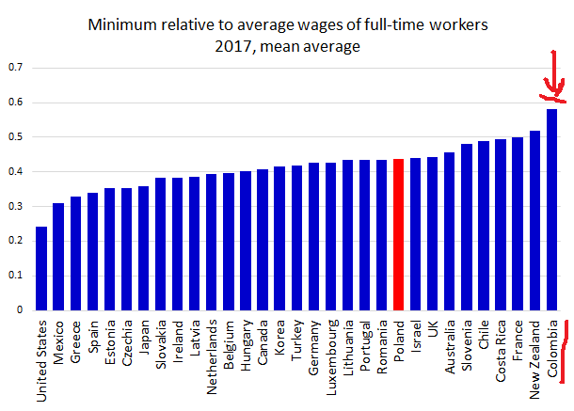

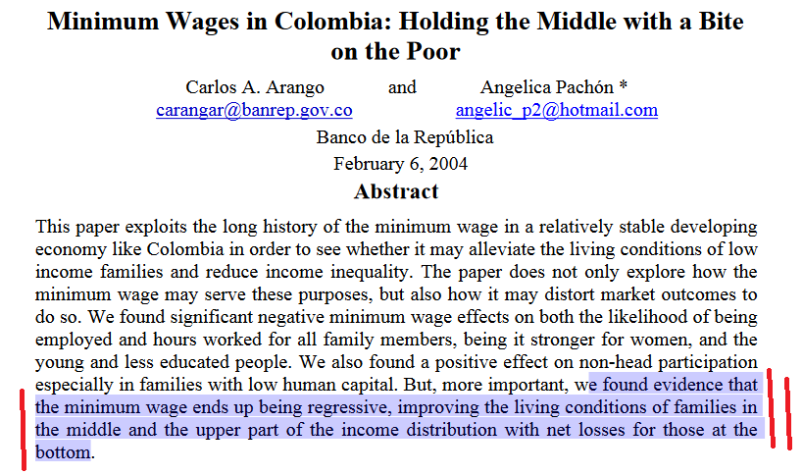

Minimum wage: global challenges and perspectives, Policy in Focus, Volume 15, Issue No. 2, September 2018, The International Policy Centre for Inclusive Growth

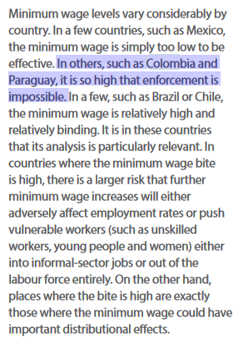

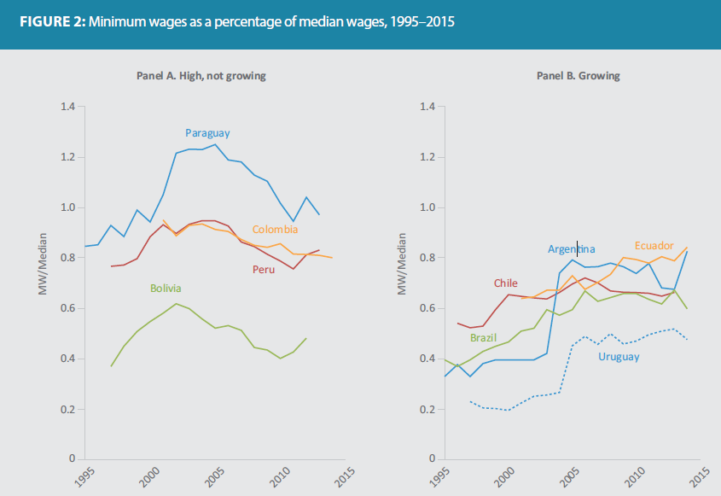

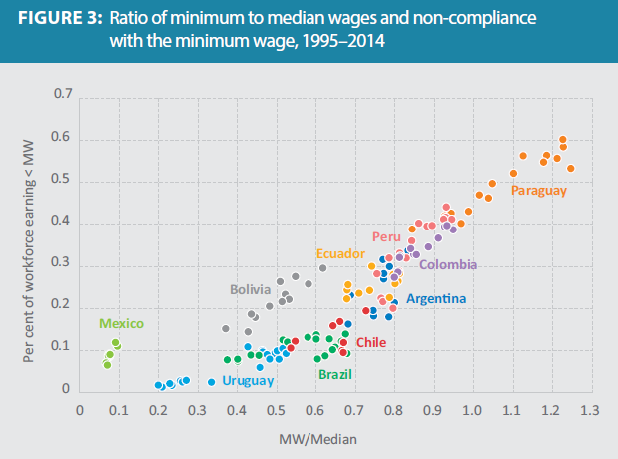

OECD Reviews of Labour Market and Social Policies: Colombia 2016, OECD

W państwach o słabych związkach zawodowych, ale wysokim ich wpływie na politykę – płaca minimalna zamiast odgrywać rolę minimum odgrywa rolę de facto płacy.

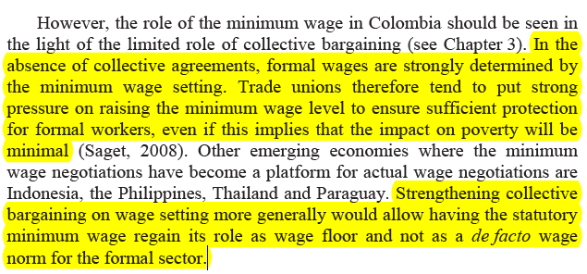

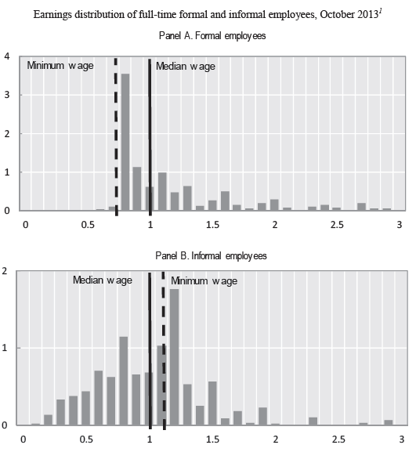

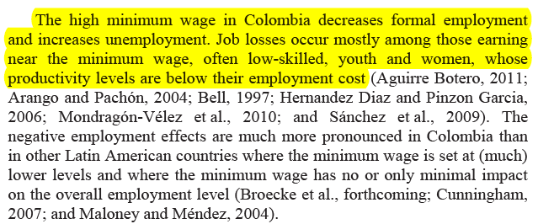

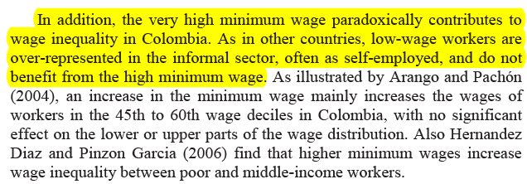

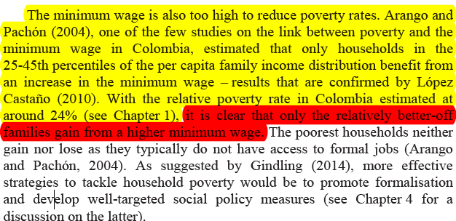

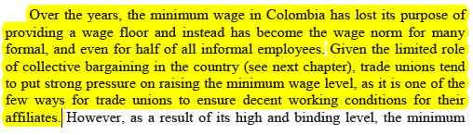
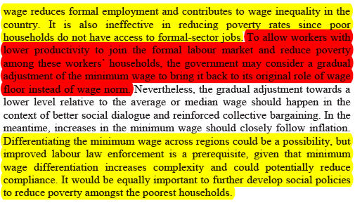

Colombia: Towards a high-income country with high social mobility / by Rafael de La Cruz, Leandro Gastón Andrián, Mario Loterzpil.

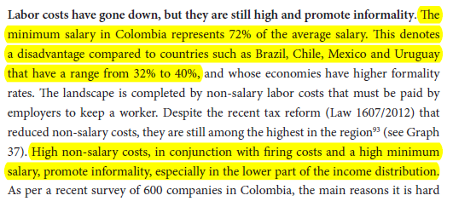

W Polsce tak samo:
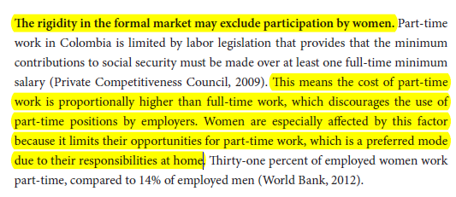

Minimum wages and social policy : lessons from developing countries, World Bank 2007

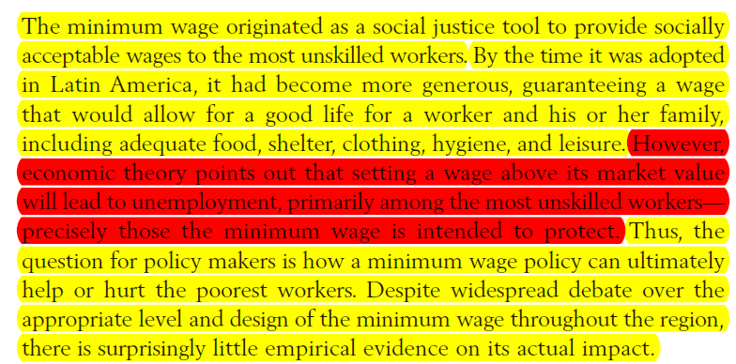

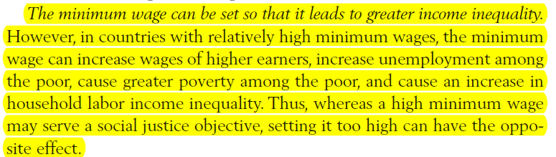

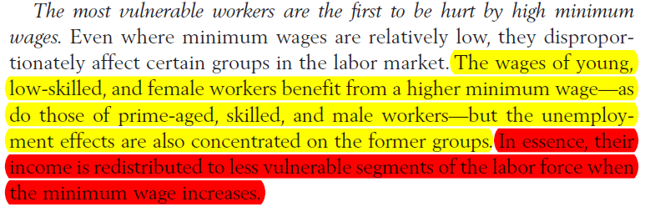

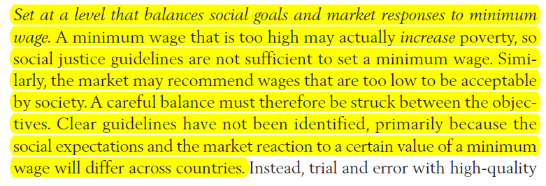

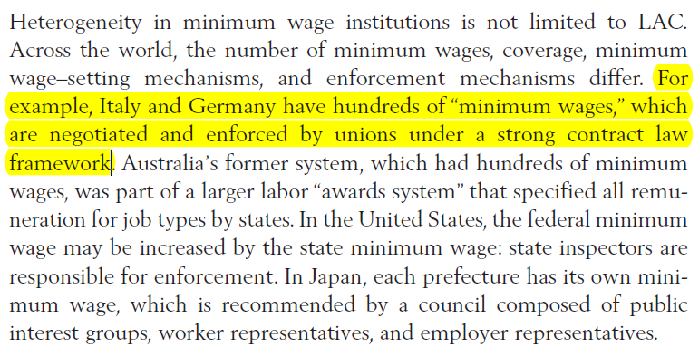

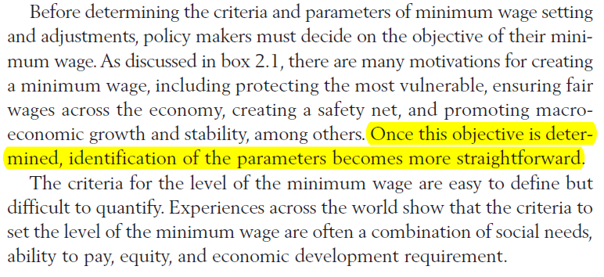

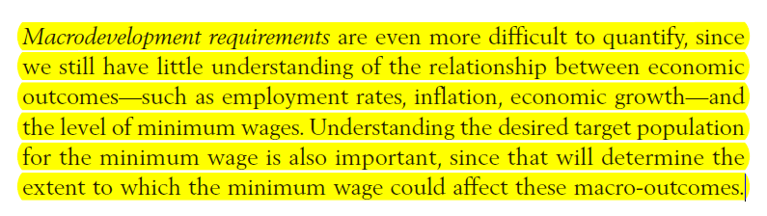

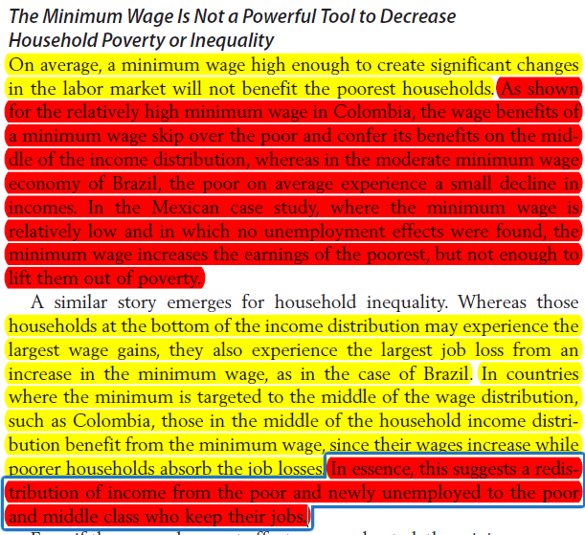

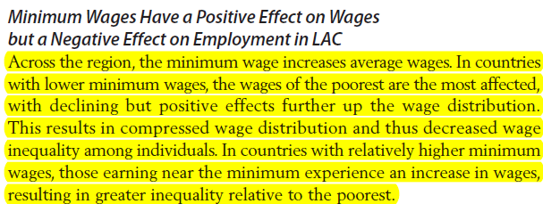

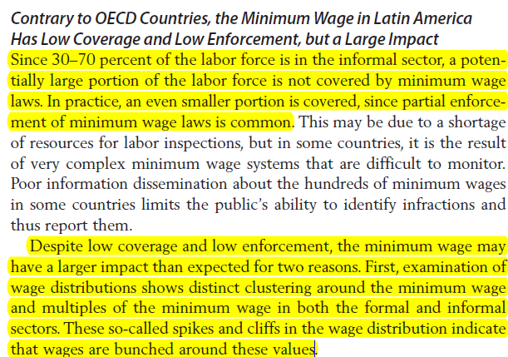

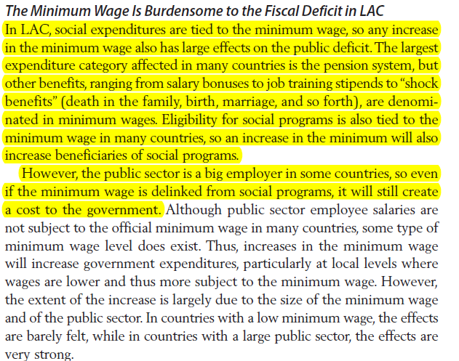

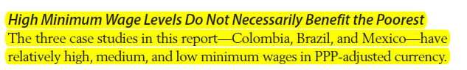
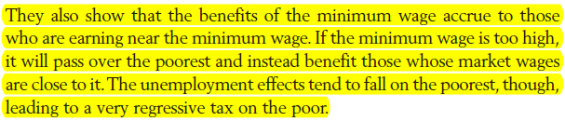

Catherine Sagat, Fixing Minimum Wage Levels in Developing Countries Common Failures and Remedies, 2006
